Restaurant Menu Page This is Restaurant Menu Page in mobile application through Android Studio
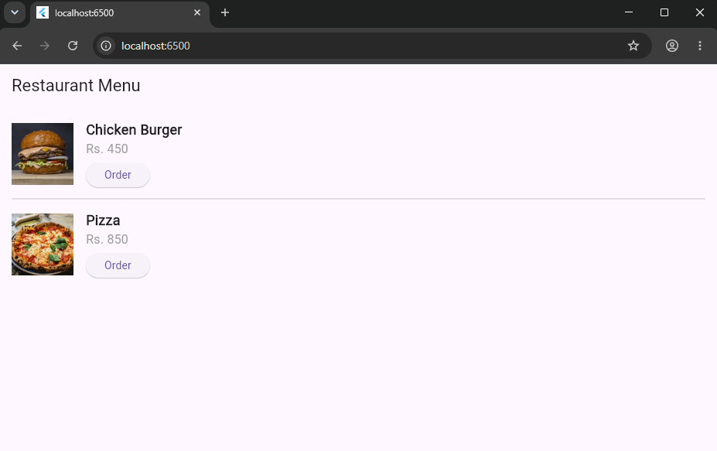

import 'package:flutter/material.dart';
void main() {
runApp(const MyApp());
}
class MyApp extends StatelessWidget {
const MyApp({super.key});
@override
Widget build(BuildContext context) {
return const MaterialApp(
debugShowCheckedModeBanner: false,
home: MenuPage(),
);
}
}
class MenuPage extends StatelessWidget {
const MenuPage({super.key});
@override
Widget build(BuildContext context) {
return Scaffold(
appBar: AppBar(
title: const Text('Restaurant Menu'),
),
body: SingleChildScrollView(
padding: const EdgeInsets.all(16.0),
child: Column(
children: [
// Item 1
Row(
children: [
Image.network(
'https://images.unsplash.com/photo-1568901346375-23c9450c58cd?w=300',
width: 80,
height: 80,
fit: BoxFit.cover,
),
const SizedBox(width: 16),
Expanded(
child: Column(
crossAxisAlignment: CrossAxisAlignment.start,
children: [
const Text(
'Chicken Burger',
style: TextStyle(fontSize: 18, fontWeight: FontWeight.bold),
),
const Text(
'Rs. 450',
style: TextStyle(fontSize: 16, color: Colors.grey),
),
const SizedBox(height: 6),
ElevatedButton(
onPressed: () {
ScaffoldMessenger.of(context).showSnackBar(
const SnackBar(
content: Text('Order successfully!'),
duration: Duration(seconds: 2),
),
);
},
child: const Text('Order'),
),
],
),
),
],
),
const Divider(height: 30),
// Item 2
Row(
children: [
Image.network(
'https://images.unsplash.com/photo-1574071318508-1cdbab80d002?w=300',
width: 80,
height: 80,
fit: BoxFit.cover,
),
const SizedBox(width: 16),
Expanded(
child: Column(
crossAxisAlignment: CrossAxisAlignment.start,
children: [
const Text(
'Pizza',
style: TextStyle(fontSize: 18, fontWeight: FontWeight.bold),
),
const Text(
'Rs. 850',
style: TextStyle(fontSize: 16, color: Colors.grey),
),
const SizedBox(height: 6),
ElevatedButton(
onPressed: () {
ScaffoldMessenger.of(context).showSnackBar(
const SnackBar(
content: Text('Order successfully!'),
duration: Duration(seconds: 2),
),
);
},
child: const Text('Order'),
),
],
),
),
],
),
],
),
),
);
}
}

